Day37 - Task18 - AWS KMS, AWS Lambda, AWS API Gateway (self-learning)
AWS KMS:
AWS Key Management Service (AWS KMS) is a managed service from Amazon Web Services that lets organizations create, manage, control, and audit cryptographic keys used to protect data.
AWS KMS is primarily a key-management service, not simply an encryption service.
Applications and AWS services can use KMS keys for cryptographic operations such as encryption and decryption, while KMS provides controls around who can use those keys and how their use is audited.
Organizations store sensitive information such as:
- Customer information
- Passwords and secrets
- Financial records
- Database information
- Application configuration
- Backup data
- Files and documents
Encryption converts readable plaintext into unreadable ciphertext.
Architecture:
AWS KMS
|
Customer Managed Key
|
v
User → S3 Bucket → Encrypted Object

Step 1: Open AWS KMS
- Sign in to the AWS Management Console.
- Select your AWS Region.
For example:
US East (N. Virginia)
us-east-1
- Search for KMS.
- Open Key Management Service.
- Create a KMS Key
From the KMS console:
KMS
↓
Customer managed keys
↓
Create key

Key type
Select: Symmetric

Key usage
Select: Encrypt and decrypt
Click Next.

Step 2: Add Key Alias
Enter:
Alias:
my-kms-s3-key
Description:
KMS key for S3 encryption hands-on activity
Click Next.

Step 3: Configure Key Administrators
AWS will ask you to select Key administrators.
Select the IAM user or role that you are using, provided it has the required permissions.
For example:
Key Administrator:
Your IAM administrator user/role
Click Next.

Step 4: Configure Key Users
You will then see Key users.
Select the IAM user or role that should be allowed to use the key.
For example:
Key User:
Your IAM user/role
Click Next.
Then click Next through the review screens and select Finish / Create key.
Step 5: Verify the KMS Key

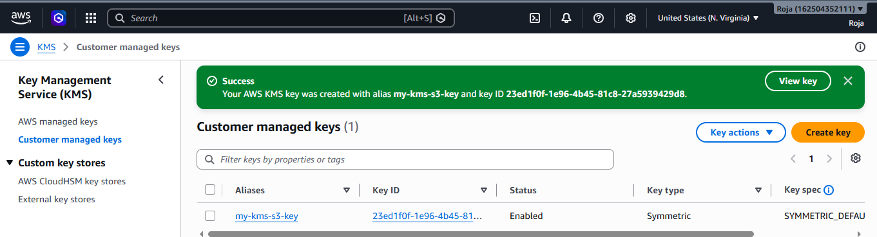

Click: my-kms-s3-key

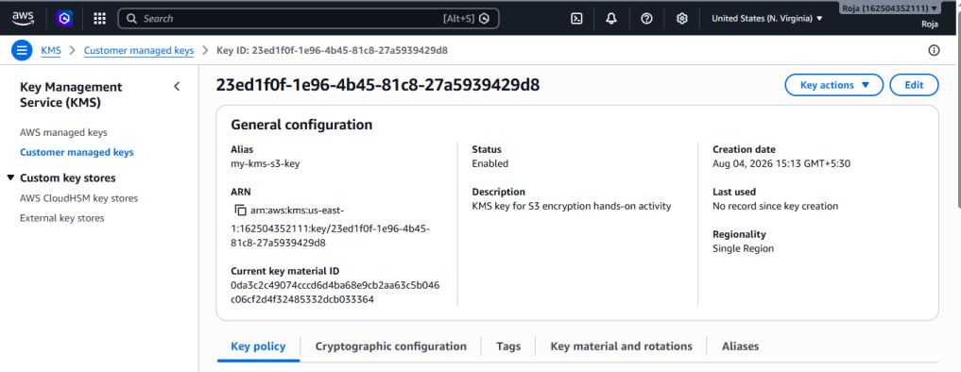

Step 6: Create an S3 Bucket
Now we'll use the KMS key with S3.
Open s3, create bucket with unique name
Keep:
Object Ownership:
ACLs disabled
For this exercise, leave:
Block Public Access:
Enabled

Click create bucket.
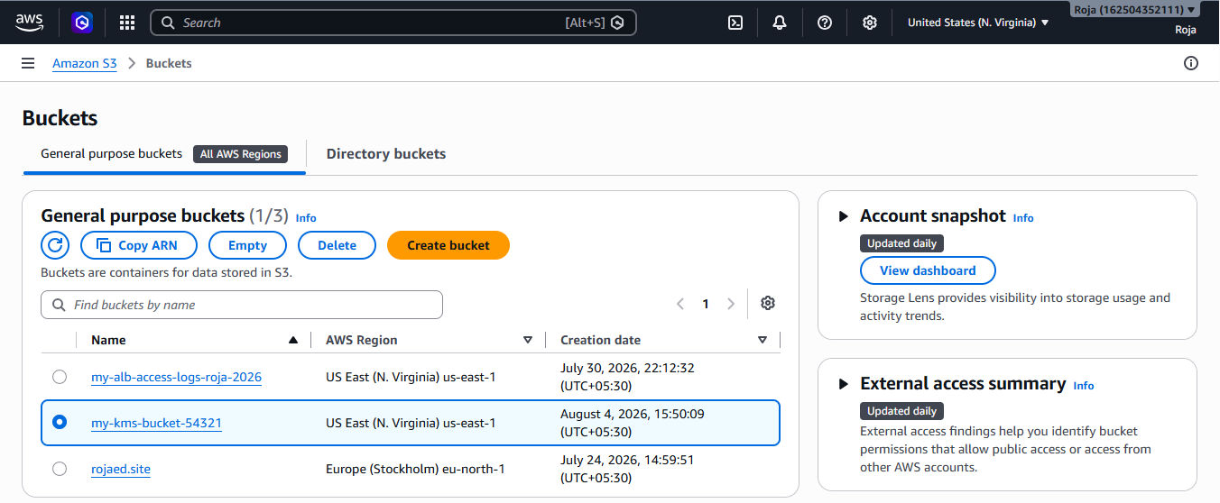

Step 7: Configure S3 Default Encryption
Open your bucket.
Go to:
Properties
↓
Default encryption
↓
Edit
Choose:
Server-side encryption
Select:
SSE-KMS
Then select:
AWS Key Management Service key
Choose:
my-kms-s3-key
Save the changes.
Your configuration should look approximately like:
Default encryption:
SSE-KMS

KMS key:
my-kms-s3-key

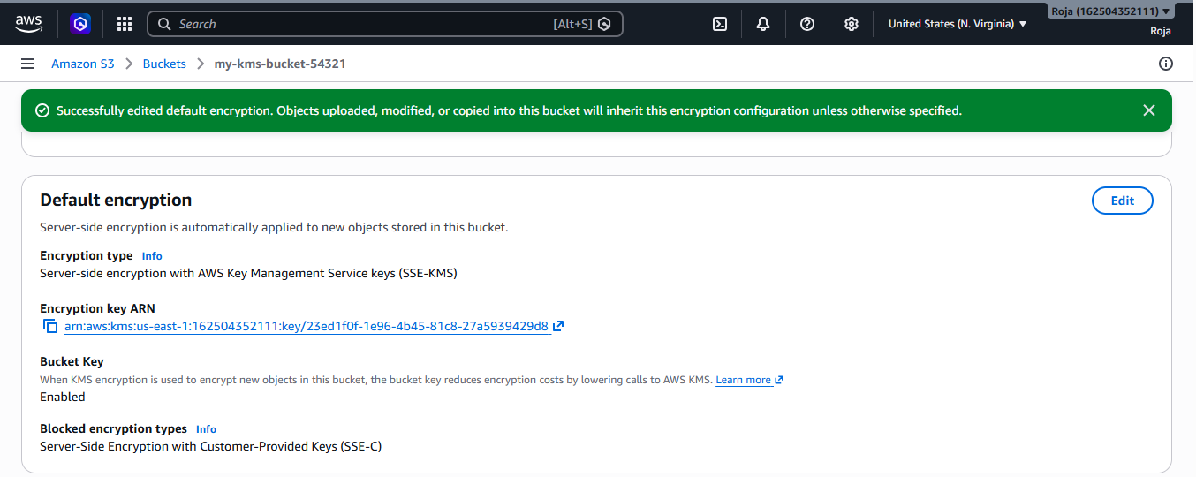

Step 8: Create a Test File
On your computer, create a simple file:
kms-test.txt
Put something like:
AWS KMS

This file is being protected using
AWS KMS server-side encryption.
Save the file.

Step 9: Upload the File to S3
Go to:
S3
↓
my-kms-bucket-54321
↓
Upload
↓
Add files
Select:
myfile.html
Click: Upload
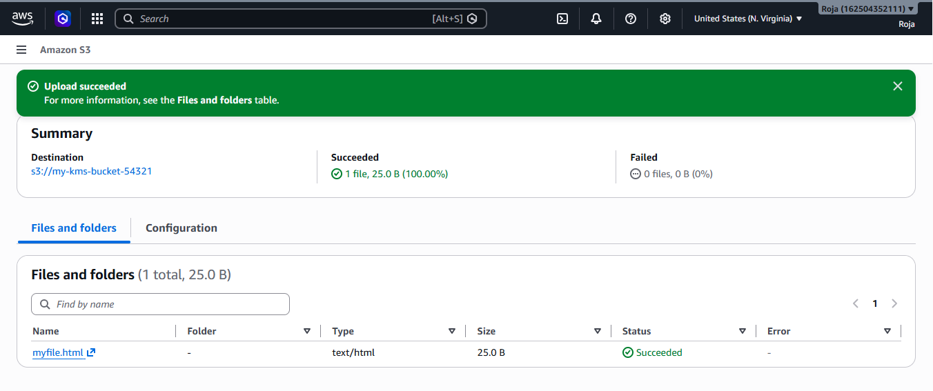

Step 10: Verify Encryption
After uploading:
- Open myfile.html
- Look at the object's Properties.
- Find the Server-side encryption section.
You should see something similar to:
Server-side encryption:
AWS Key Management Service key (SSE-KMS)

AWS KMS key:
my-kms-s3-key

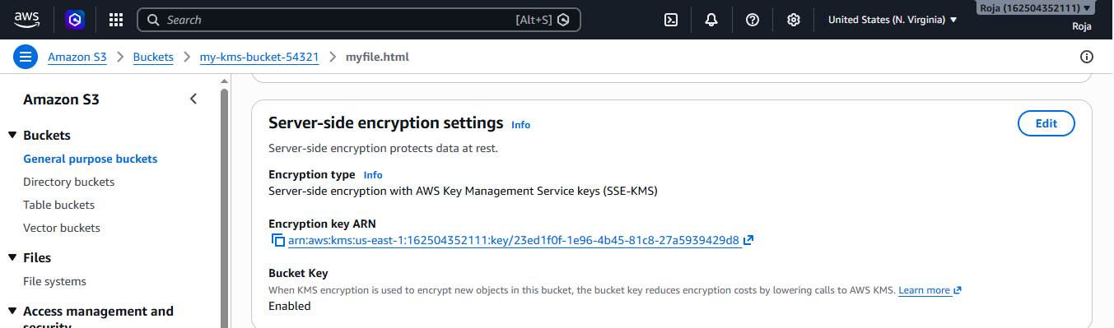

Step 11: Monitor KMS Activity Using CloudTrail
Open:
CloudTrail
↓
Event history
Search/filter for KMS-related events.
You may see events associated with operations such as:
Encrypt
Decrypt
GenerateDataKey
This demonstrates:
KMS Operation
↓
CloudTrail
↓
Audit Information
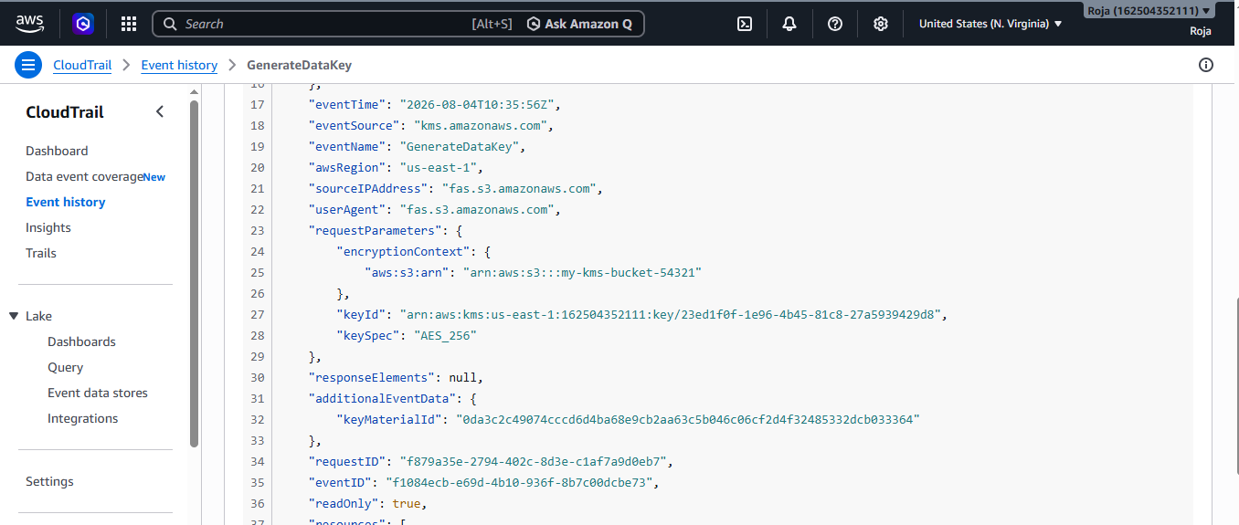

AWS Lambda:
AWS Lambda is a serverless, event-driven compute service provided by Amazon Web Services (AWS). It allows you to run application code without provisioning, managing, or maintaining servers.
With Lambda, you upload your code as a Lambda function, and AWS automatically handles the underlying infrastructure, including server management, capacity, scaling, and availability.
Lambda executes your code when an event or request occurs. For example, a Lambda function can be triggered when a file is uploaded to Amazon S3, an API request is received through API Gateway, or a message arrives in Amazon SQS.
Objective
To understand AWS Lambda and implement a serverless function that runs code without provisioning or managing servers.
AWS Services Used
- Amazon Web Services (AWS)
- AWS Lambda
- AWS IAM
- Amazon CloudWatch
Architecture:
Without Lambda
Suppose you have a web application.

User
│
▼
Server (Running 24/7)
│
▼
Application
You pay for the server even when nobody is using it.
With Lambda
User
│
▼
Event
│
▼
AWS Lambda
│
▼
Runs Code
│
▼
Response

Prerequisites
- AWS account
- Access to AWS Management Console
- IAM permissions to create Lambda functions
- Basic knowledge of Python
Step 1: Open AWS Lambda
- Log in to the AWS Management Console.
- Make sure you select the required AWS Region.
- Search for Lambda in the AWS search bar.
- Open Lambda.
Step 2: Create a Lambda Function
- Click Create function.
- Select Author from scratch.
- Enter the following:
Setting | Value
Function name | MyFirstLambdaFunction
Runtime | Python 3.x
Architecture | x86_64
Permissions | Create a new role with basic Lambda permissions
- Click Create function.
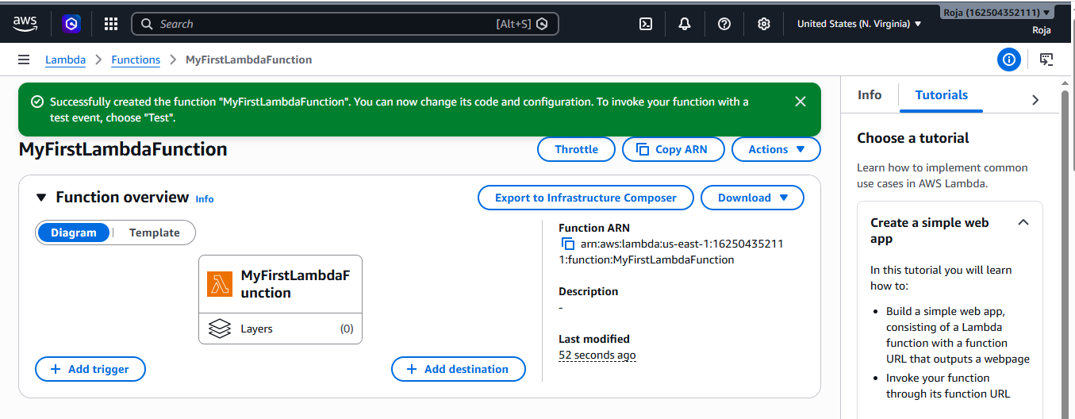

Step 3: Add Lambda Function Code
In the Code source section, replace the existing code with:
import json

def lambda_handler(event, context):
print("Hello from AWS Lambda!")

return {
'statusCode': 200,
'body': json.dumps('Hello from AWS Lambda!')
}
Click Deploy.
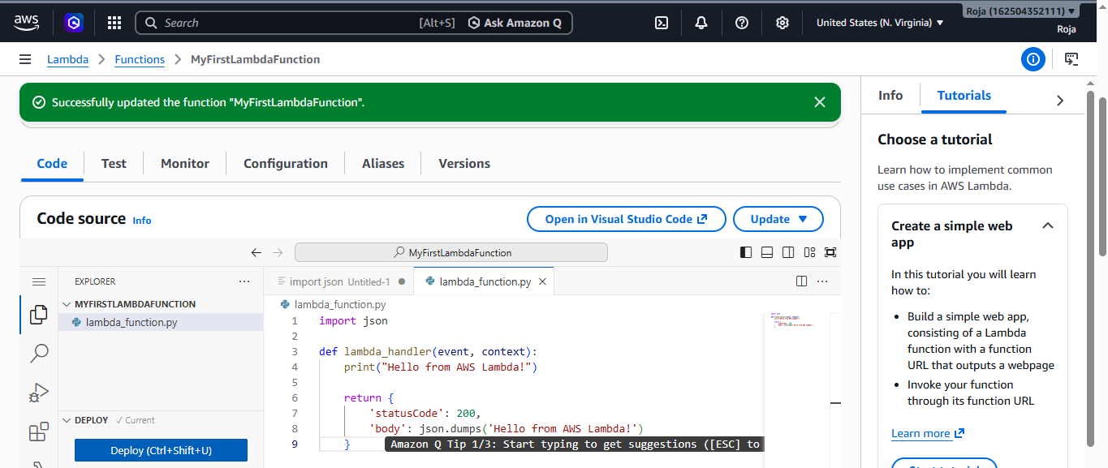

Step 4: Create a Test Event
- Click Test.
- Select Create new event.
- Enter:
Event name: MyTestEvent
- Keep the default JSON event or use:
{
"message": "Testing Lambda"
}
- Click Save.

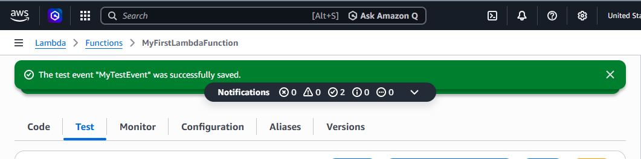

Step 5: Test the Lambda Function
Click Test.
You should see a successful execution similar to:
Execution result: succeeded
The response should contain:
{
"statusCode": 200,
"body": "\"Hello from AWS Lambda!\""
}
This confirms that your Lambda function executed successfully.
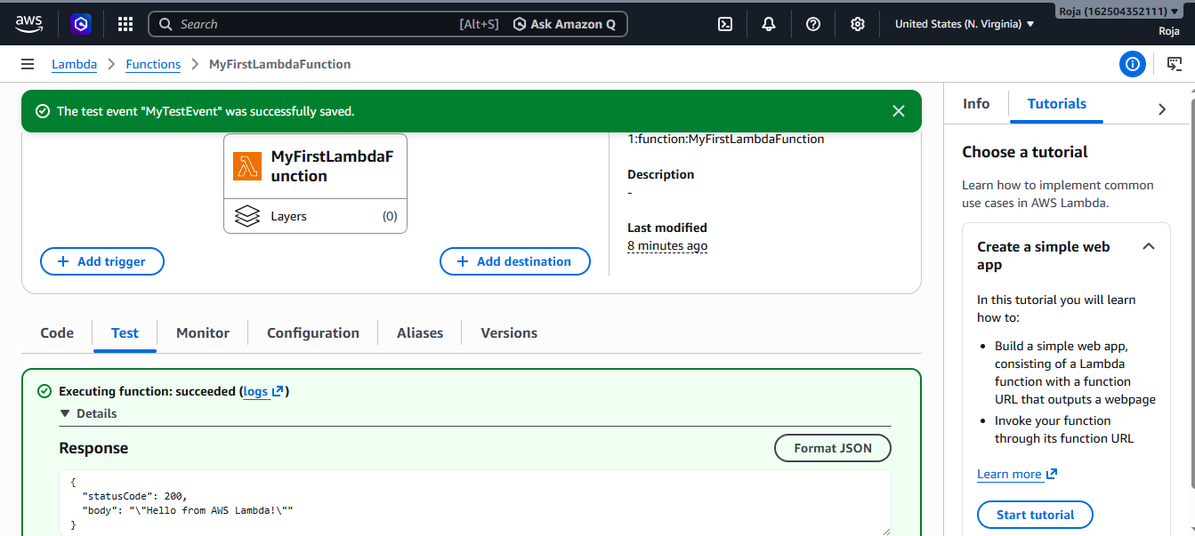

Step 6: Verify CloudWatch Logs
Lambda automatically sends execution logs to Amazon CloudWatch Logs when the execution role has the required basic logging permissions.
- Open your Lambda function.
- Go to Monitor.
- Select View CloudWatch logs.
- Open the relevant Log group.
- Open the latest Log stream.
You should find:
Hello from AWS Lambda!
This confirms that the Lambda function executed and generated logs.
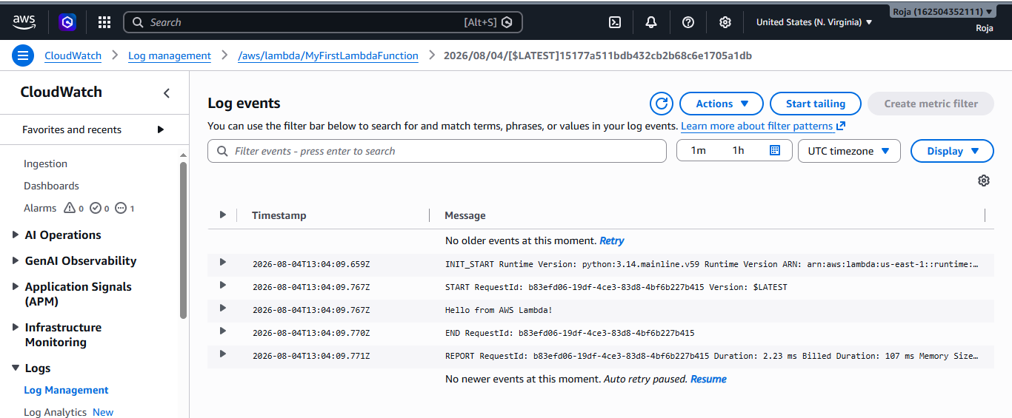
Amazon API Gateway:
Amazon API Gateway is an AWS service used to create, publish, monitor, and secure APIs.
It acts as a gateway between clients and backend services such as Lambda.
API Gateway can handle things such as:
- HTTP/REST APIs
- Request routing
- Authentication and authorization
- Throttling
- Monitoring
- API deployment
- Integration with Lambda and other backend services
Common HTTP Methods in API Gateway
- In AWS API Gateway, HTTP methods define what action the client wants to perform on a resource.
- The most common methods are:
HTTP Method | Purpose | Example
GET | Retrieve data | Get user details
POST | Create new data | Create a new user
PUT | Update/replace existing data | Update user details
PATCH | Partially update data | Update only user's email
DELETE | Delete data | Delete a user

Architecture
Users / Clients
|
↓
Amazon API Gateway
|
┌───────────┼───────────┐
↓ ↓ ↓
Lambda EC2/ALB Other AWS
| | services
↓ ↓
DynamoDB RDS

Prerequisite
Before creating API Gateway, you should have: AWS Lambda function
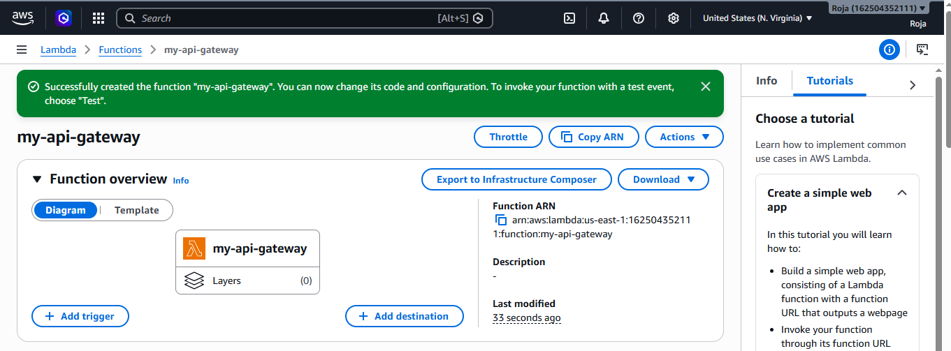

Deployed code

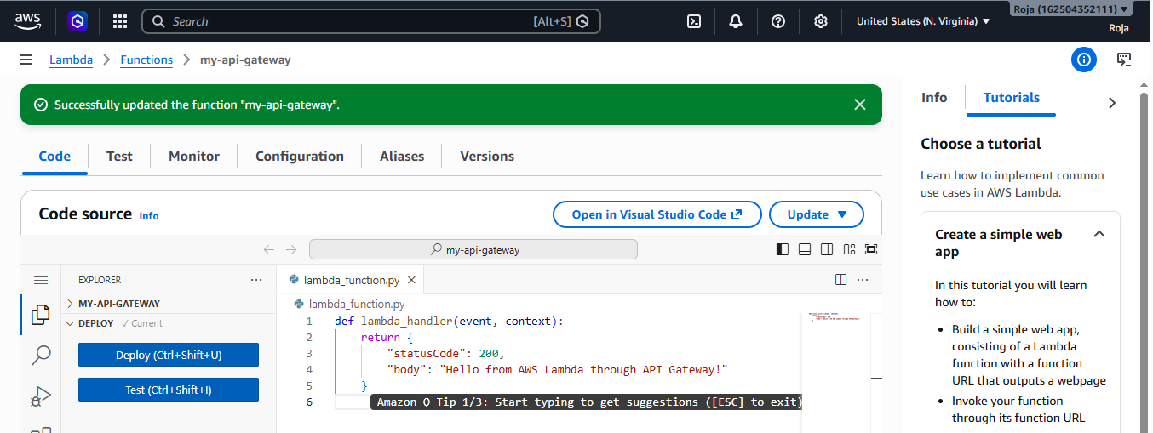

Tested the code:
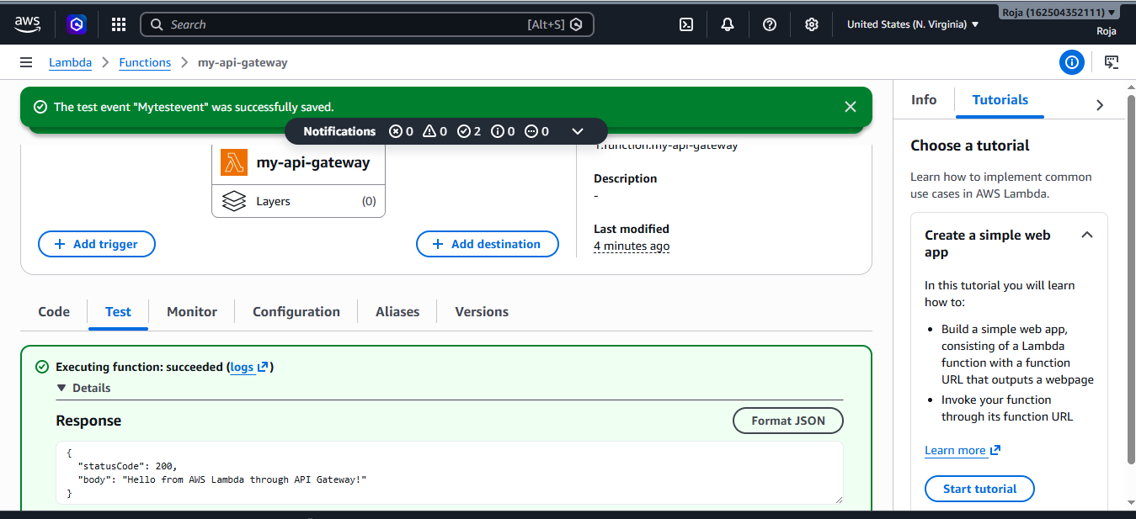
Step 1: Create API Gateway
Go to: AWS Console → API Gateway
Click: Create API
You will see different API types.
For this exercise, choose: REST API → Build
Create new API: New API
API name: Lambda-API-Demo
Endpoint Type: Regional
Click: Create API
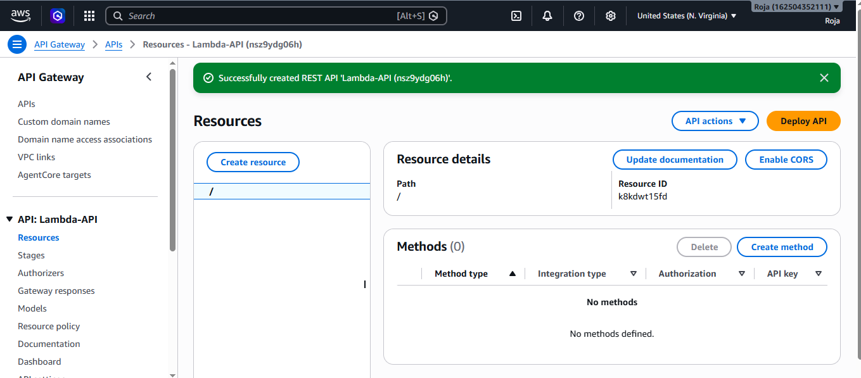

Step 2: Create a Resource
After creating the API, you need to create a resource.
Go to: Resources → Create Resource
Enter: Resource Name: hello
The resource path will become:
/hello
Click: Create Resource
Your API will look like:
Lambda-API-Demo
│
└── /hello

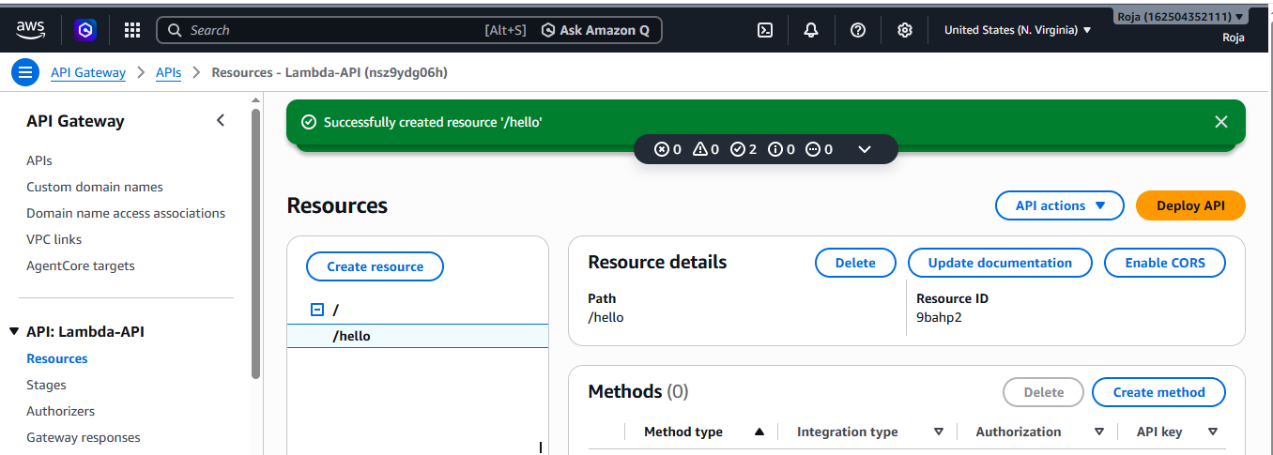

Step 2: Create a GET Method
Select:
/hello
Click: Create method
Select: GET
For the integration type, select: Lambda Function
Select your Lambda function: my-api-gateway
Make sure the AWS Region is correct.
If you see an option similar to:
Grant API Gateway permission to invoke your Lambda function, allow it.
Click Create method.
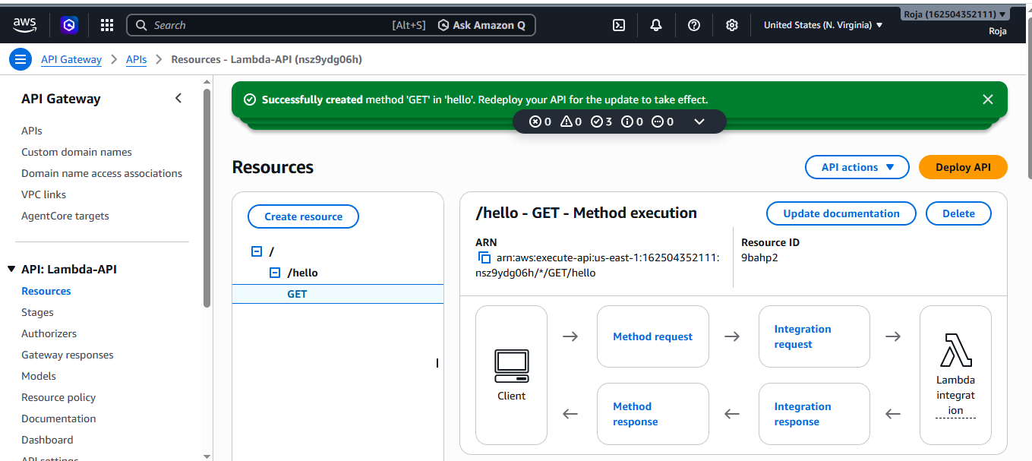

Step 3: Test the API
Before deploying it, test the method.
Select: GET → Test
Click: Test
You should receive a response similar to:
Status: 200

Hello from AWS Lambda through API Gateway!
This verifies:
API Gateway
↓
Lambda
↓
Response

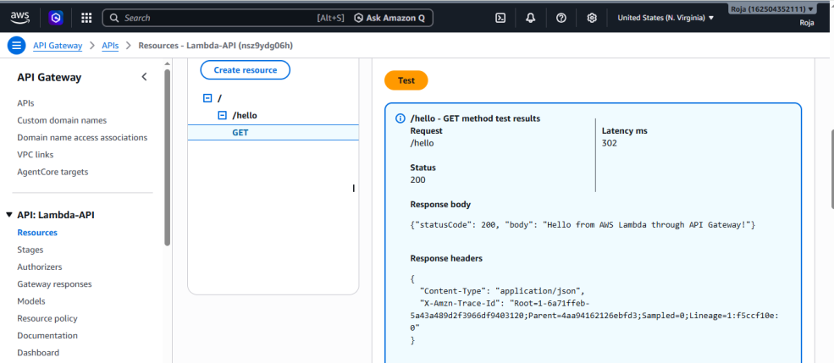

Step 4: Deploy the API
This is an important step.
Creating the API and method does not automatically make the API available through its public URL.
Click: Deploy API
Create a new stage.
Enter: Stage name: dev
Click: Deploy
Your API is now deployed to the dev stage.
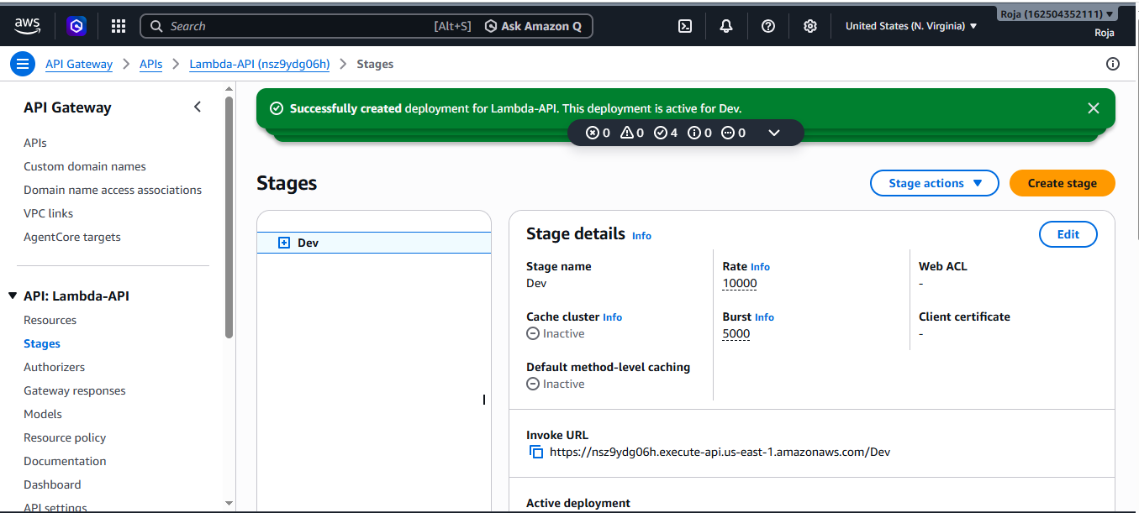

Step 5: Get the Invoke URL
After deployment, API Gateway will provide an Invoke URL.
It will look approximately like:
https://xxxxxxxxxx.execute-api.<region>.amazonaws.com/dev
Your complete endpoint will be:
https://xxxxxxxxxx.execute-api.<region>.amazonaws.com/dev/hello
Open the endpoint in your browser.
You should receive:
Hello from AWS Lambda through API Gateway!

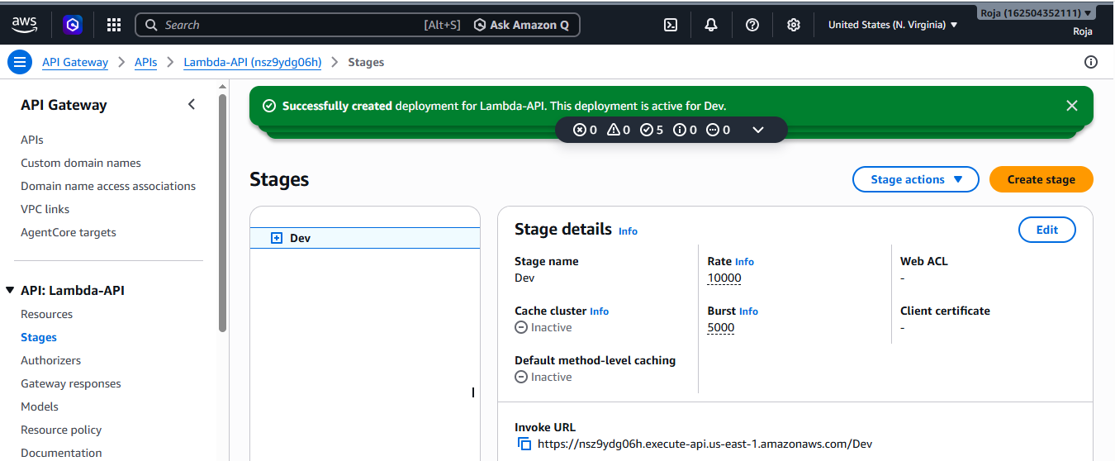

Step 6: Test Using Browser
Open:
https://xxxxxxxxxx.execute-api.<region>.amazonaws.com/dev/hello
You should see: Hello from AWS Lambda through API Gateway!
This means your implementation is successful.
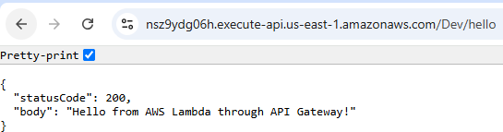

Step 7: Test Using Command Line
You can also test it using curl: curl https://xxxxxxxxxx.execute-api.<region>.amazonaws.com/dev/hello
Expected output:
Hello from AWS Lambda through API Gateway!
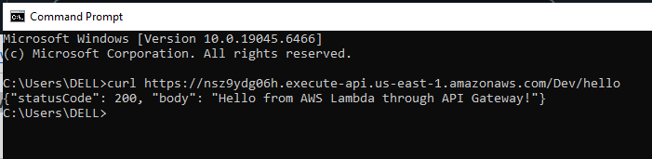

Step 8: Check CloudWatch Logs
Your Lambda execution logs can be viewed in CloudWatch Logs.
Go to: AWS Console → CloudWatch → Logs → Log groups
Look for: /aws/lambda/api-gateway-demo
Open the latest Log stream.
You can see information about the Lambda invocation.
Your Lambda execution role should have:
AWSLambdaBasicExecutionRole
which allows the function to write basic execution logs to CloudWatch.
